CWC2020 Turbine Team

Hardware Review

Lucas Duncan
Ethan Malteverne
Daniel Massaglia
Marina McCue
Matt Mennell
Sean Veden

2019-2020



Project Sponsor: Gore
Faculty Advisor: David Willy
Instructor: Dr. David Trevas

Introduction

Braking Prototype
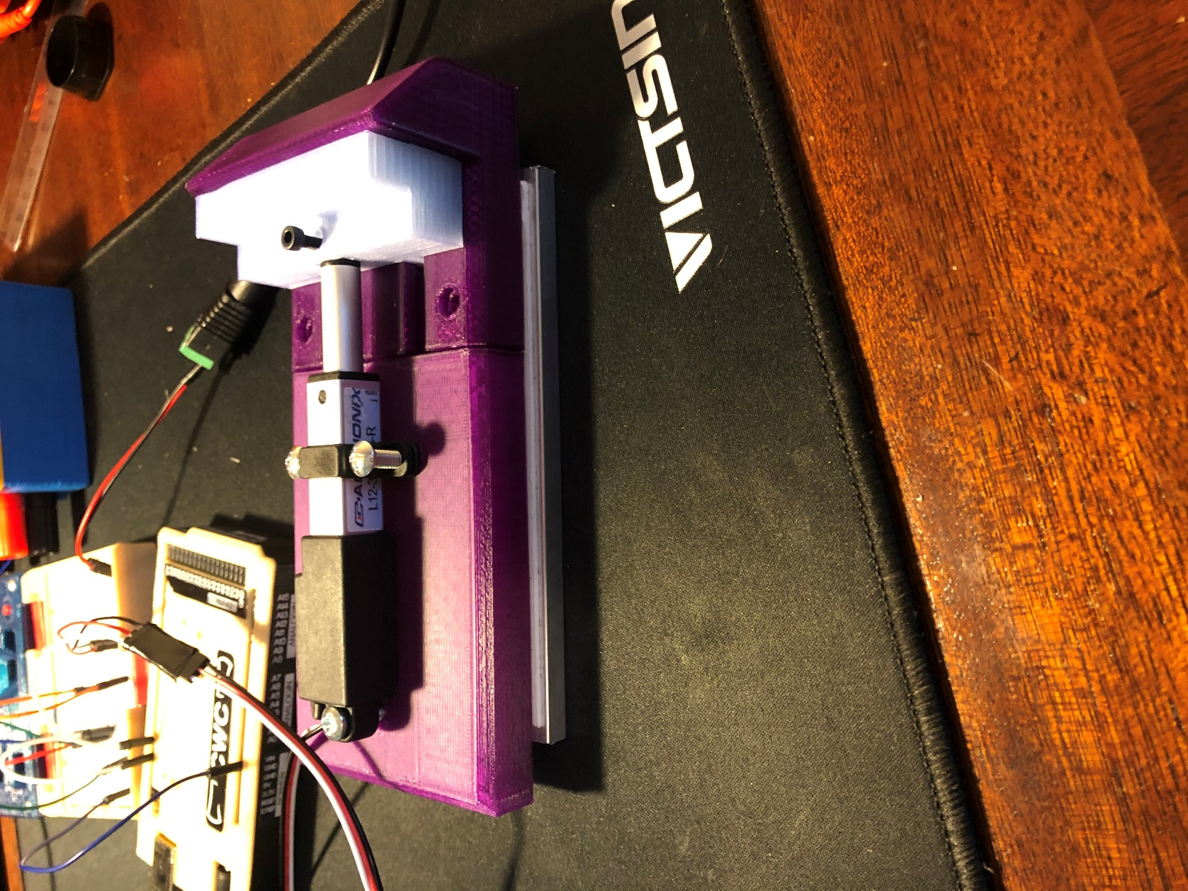
Figure ## - Fully Closed Extended Stroke
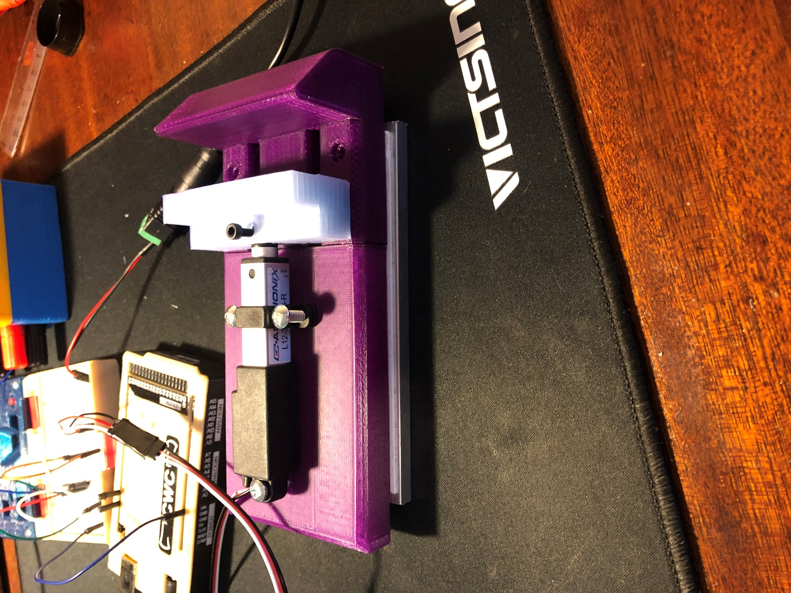
Figure ## - Retracted Stroke
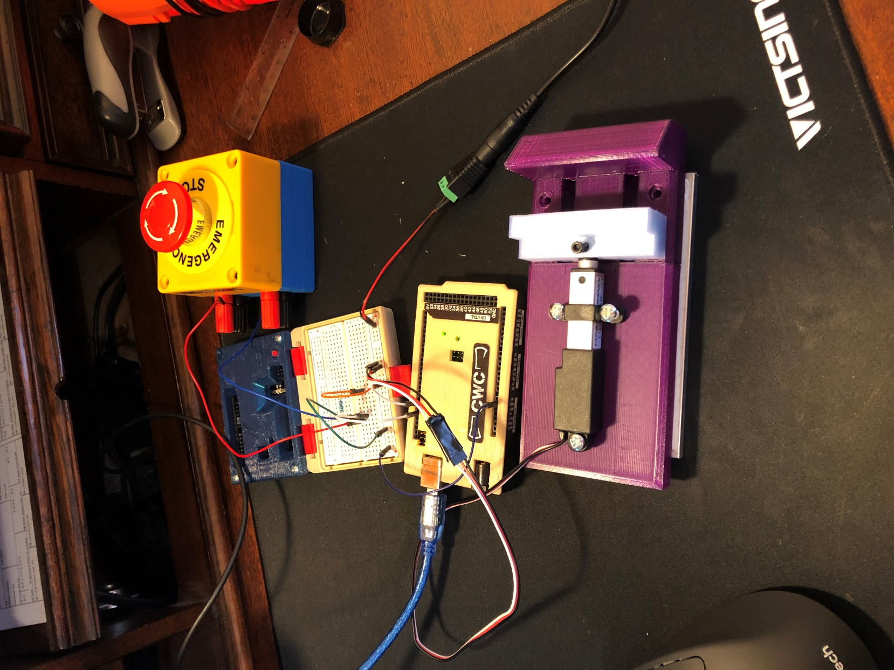
Figure ## - Fully System: Button, Circuit, & Brake
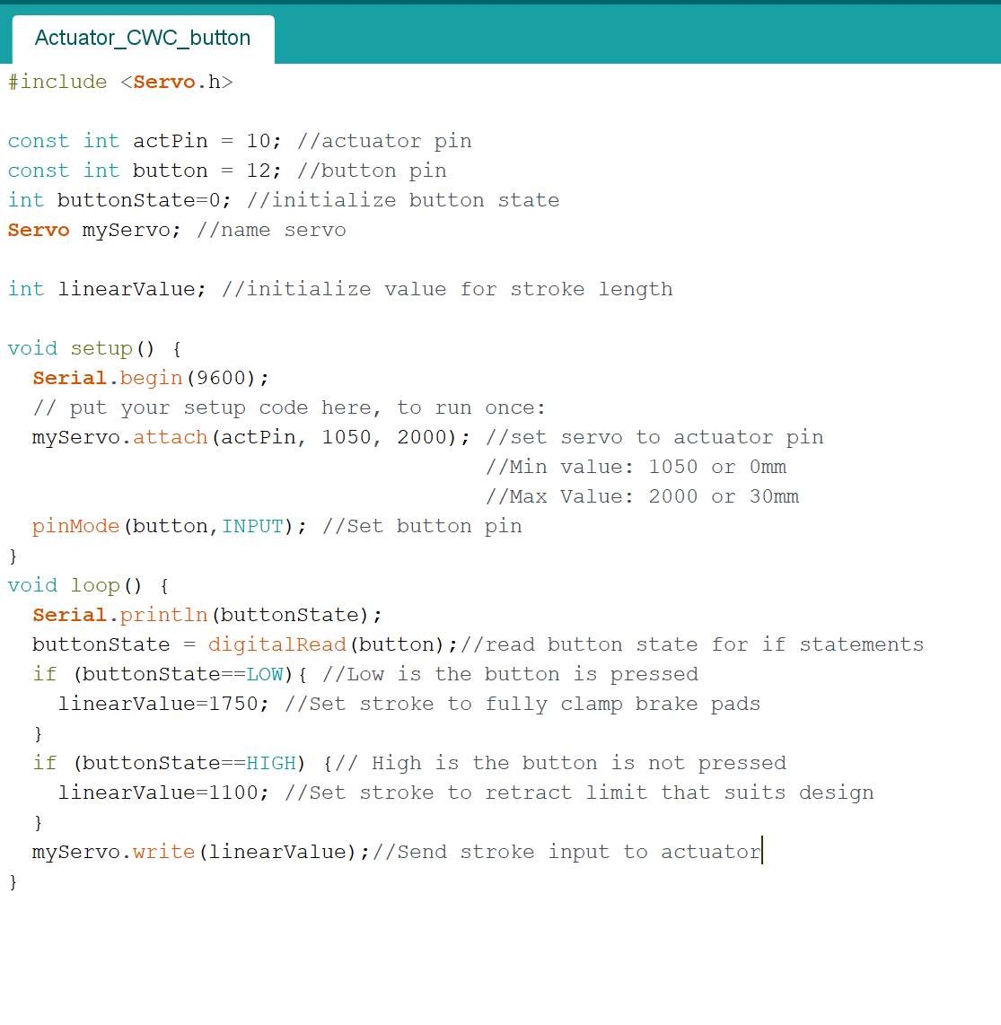Figure ## - Prototype Braking System Arduino Code

